DATA HANDLING AND VISUALIZATION USING R
ASSIGNMENT 14 – SURVEY RESULTS
DATASET
Respondent | Question 1 | Question 2 | Question 3
1 | A | B | C
2 | B | A | D
3 | C | A | B
QUESTION 1: Create a stacked bar chart to display the distribution of answers for Question 1. Label the chart elements.
AIM
To create a stacked bar chart showing the distribution of responses for Question 1.
ALGORITHM
1. Create the survey response data frame.
2. Count the number of respondents for each answer in Question 1.
3. Create a stacked bar chart using the response categories.
4. Add title, axis labels, and answer labels.
5. Display the chart.
R CODE
data <- data.frame(
Respondent = c(1, 2, 3),
Question1 = c("A", "B", "C"),
Question2 = c("B", "A", "A"),
Question3 = c("C", "D", "B")
)
library(ggplot2)
ggplot(data, aes(x = "Question 1", fill = Question1)) +
geom_bar() +
labs(
title = "Distribution of Answers for Question 1",
x = "Question",
y = "Number of Responses",
fill = "Answer"
) +
theme_minimal()
OBSERVATION
Question 1 has three responses: A, B, and C. Each answer occurs once, so the three answer categories have equal frequency.
RESULT
The stacked bar chart for the distribution of Question 1 responses was successfully created and labelled.
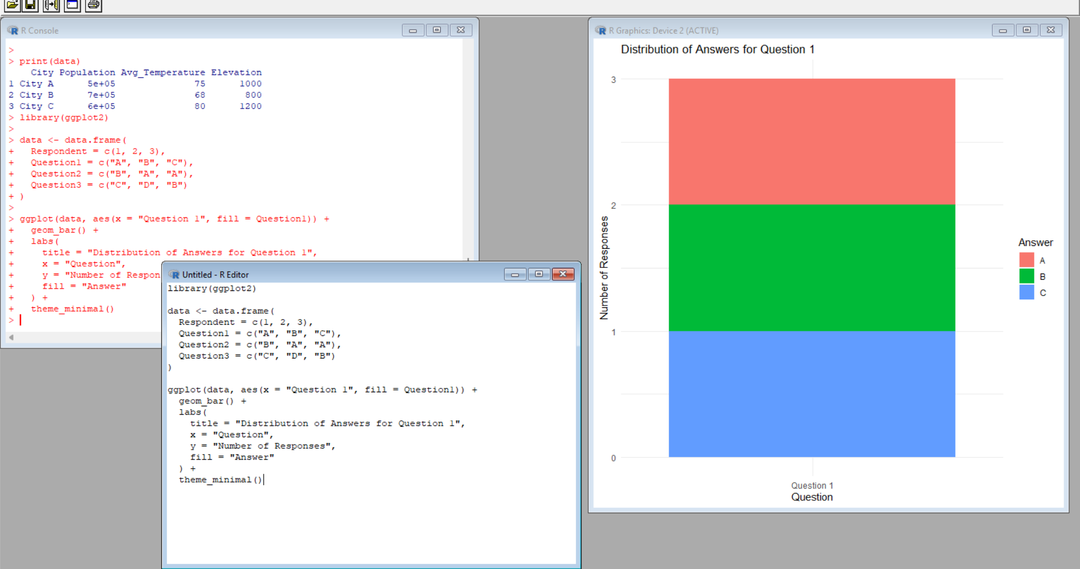
QUESTION 2: Generate a radar chart to visualize the overall pattern of responses across all three questions.
AIM
To generate a radar chart representing the overall response pattern across Questions 1, 2, and 3.
ALGORITHM
1. Create the survey data frame.
2. Convert answer categories A, B, C, and D into numerical scores.
3. Calculate the average score for each question.
4. Prepare the values in radar-chart format.
5. Create the radar chart and label the questions.
6. Display the overall response pattern.
R CODE
data <- data.frame(
Respondent = c(1, 2, 3),
Question1 = c("A", "B", "C"),
Question2 = c("B", "A", "A"),
Question3 = c("C", "D", "B")
)
library(fmsb)
score <- function(x) match(x, c("A", "B", "C", "D"))
q1 <- mean(score(data$Question1))
q2 <- mean(score(data$Question2))
q3 <- mean(score(data$Question3))
radar_data <- data.frame(
Question1 = c(4, 1, q1),
Question2 = c(4, 1, q2),
Question3 = c(4, 1, q3)
)
radar_data <- rbind(
Max = c(4, 4, 4),
Min = c(1, 1, 1),
Average = c(q1, q2, q3)
)
radar_data <- radar_data[, c("Question1", "Question2", "Question3")]
radarchart(
radar_data,
axistype = 1,
title = "Overall Pattern of Survey Responses",
pcol = 1,
plwd = 2,
cglty = 1,
axislabcol = "black"
)
OBSERVATION
The radar chart compares the average response scores across the three questions. Question 2 has the lowest average score, while Question 3 has the highest average score among the three questions.
RESULT
A radar chart was successfully generated to visualize the overall response pattern across all three survey questions.
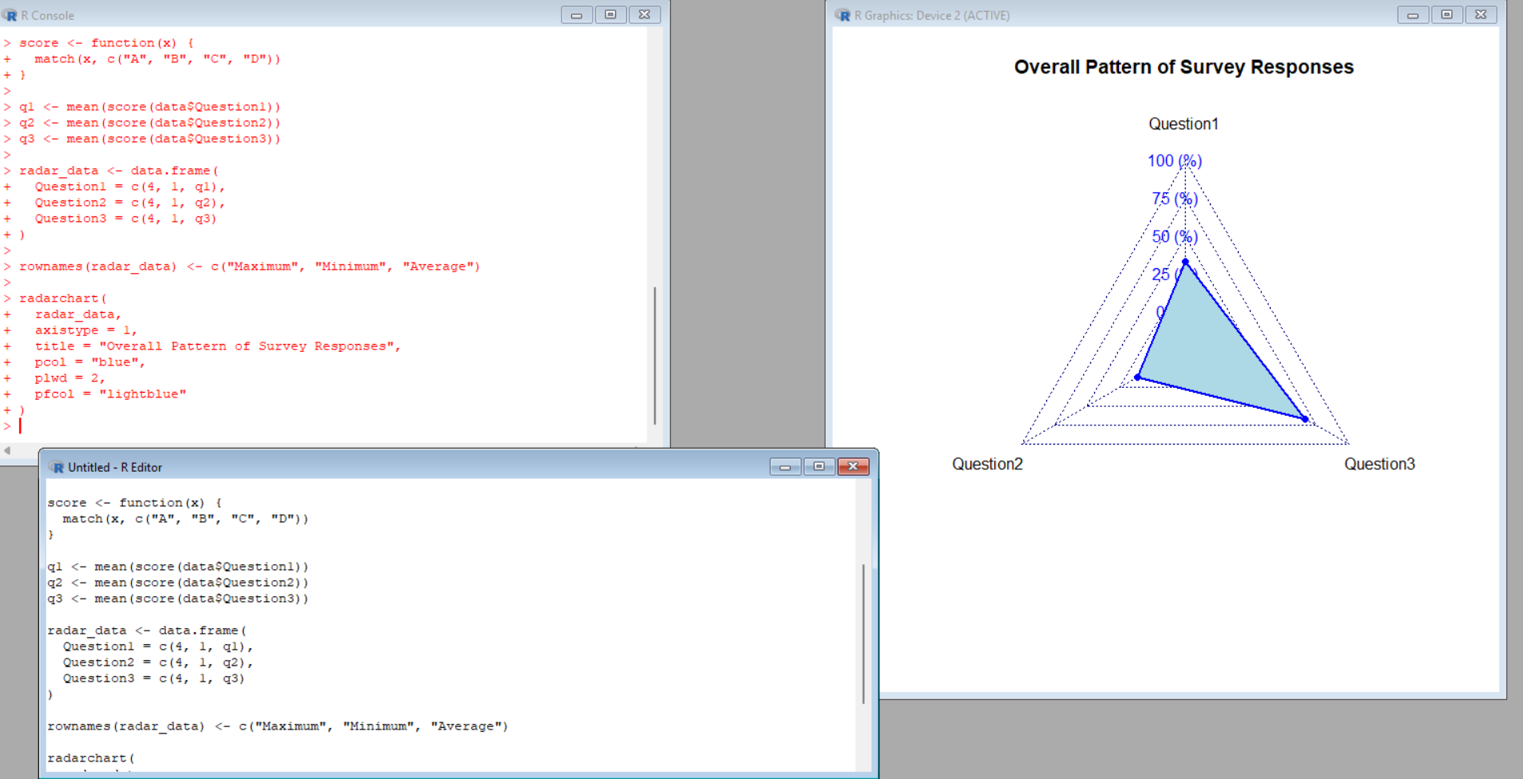
QUESTION 3: Build a table to show the survey response data for each respondent. Label the table elements.
AIM
To display the survey responses of each respondent in a clearly labelled table.
ALGORITHM
1. Create the survey response data frame.
2. Include Respondent, Question 1, Question 2, and Question 3.
3. Display all responses in table form.
4. Add proper column labels.
R CODE
data <- data.frame(
Respondent = c(1, 2, 3),
Question1 = c("A", "B", "C"),
Question2 = c("B", "A", "A"),
Question3 = c("C", "D", "B")
)
print(data)
OBSERVATION
The table clearly displays the responses of all three respondents for the three questions.
RESULT
The survey response data was successfully displayed in a labelled table.
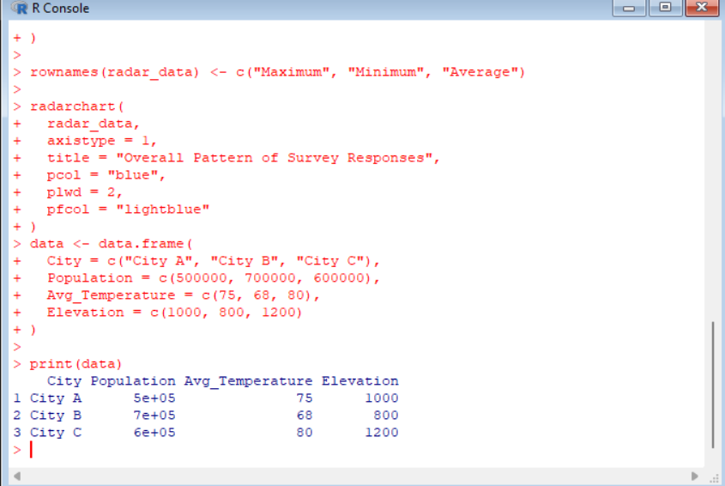

QUESTION 4: Develop a Tableau dashboard combining the stacked bar chart, radar chart, and the table for interactive exploration of survey responses.
AIM
To develop an interactive Tableau dashboard by combining the stacked bar chart, radar chart, and survey response table.
ALGORITHM
1. Open Tableau Desktop or Tableau Public.
2. Connect to the survey response dataset.
3. Create a stacked bar chart showing the distribution of Question 1 answers.
4. Create a radar chart to display the overall response pattern across Questions 1, 2, and 3.
5. Create a table containing Respondent, Question 1, Question 2, and Question 3.
6. Create a new dashboard.
7. Drag the stacked bar chart, radar chart, and table into the dashboard.
8. Add suitable titles and labels.
9. Add filters or highlighting for interactive exploration.
10. Save the dashboard.
TABLEAU PROCEDURE
1. Stacked Bar Chart: Place Question 1 as the category and Answer as the color/detail field. Use the number of responses as the measure.
2. Radar Chart: Use the summarized average response scores for Question 1, Question 2, and Question 3. In Tableau, a radar chart can be created using a polygon/path technique or a suitable radar-chart template.
3. Table: Add Respondent, Question 1, Question 2, and Question 3 to the view.
4. Dashboard: Combine the three sheets in one dashboard and apply suitable formatting and filters.
OBSERVATION
The Tableau dashboard combines the response distribution, overall response pattern, and individual respondent data in one interactive view. It helps users compare survey responses easily.
RESULT
An interactive Tableau dashboard was successfully designed by combining the stacked bar chart, radar chart, and survey response table.
OVERALL RESULT
All four questions were completed separately using the given Survey Results dataset. The responses were visualized using a stacked bar chart, radar chart, table, and an interactive Tableau dashboard.

